**Practical no. 8**

**FS19CO042**

**Aim:** Connect your system to the internet

**Tool used:** Cisco Packet tracer student software.

**Required components:** Wireless router, PC, Laptop

**Theory and steps:**

**Prepare proper topology**

1. Place end devices and connect a wireless router. Connect Wireless router to Internet Cloud via a cable Modem. Create a sample server and connect to internet cloud.
2. Open Packet tracer and add network devices to topology.  
   To place device, choose device from bottom-left device options and place anywhere on the workspace.  
   (Optional) To change network devices name, click on device and under Config tab->Global, Edit the display name as per your choice.  
   Place wireless router, PC, laptop, Internet cloud, Cable modem and exemplary server.  
   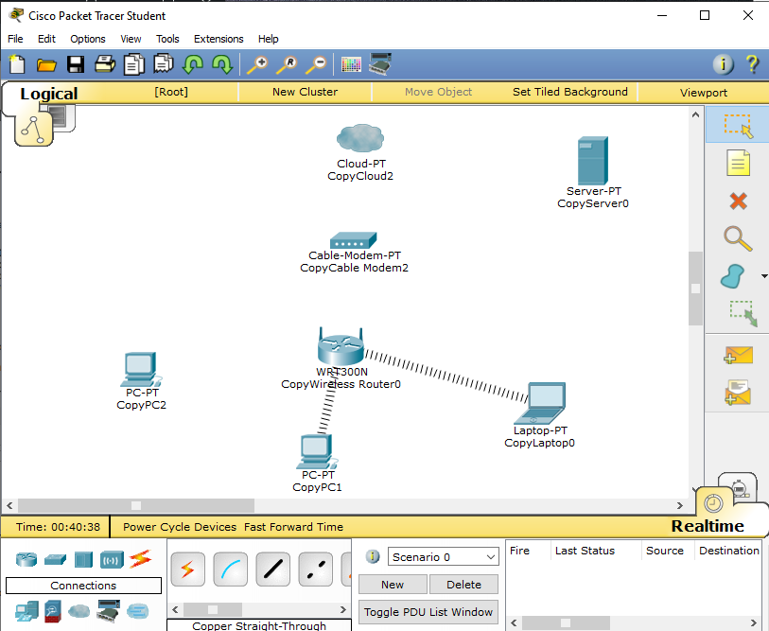  
   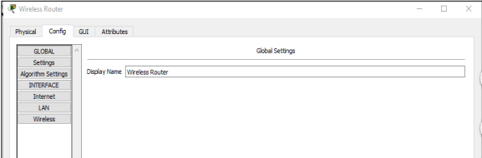
3. Add physical connections between devices. Wireless devices connect automatically after some time.  
     
   Using the device selection box, select type of physical cabling, click on device1, select appropriate port and then device2 and corresponding port on it.  
     
   PC -> Wireless Router = Connect using copper straight through cable.  
   Wireless Router -> Cable Modem = Connect using a copper straight through cable  
   Cable Modem -> Internet cloud = Connect using a coaxial cable.  
   Internet cloud -> Server = Connect using copper straight-through cable.  
     
   Add necessary ports if not available on some devices.  
     
   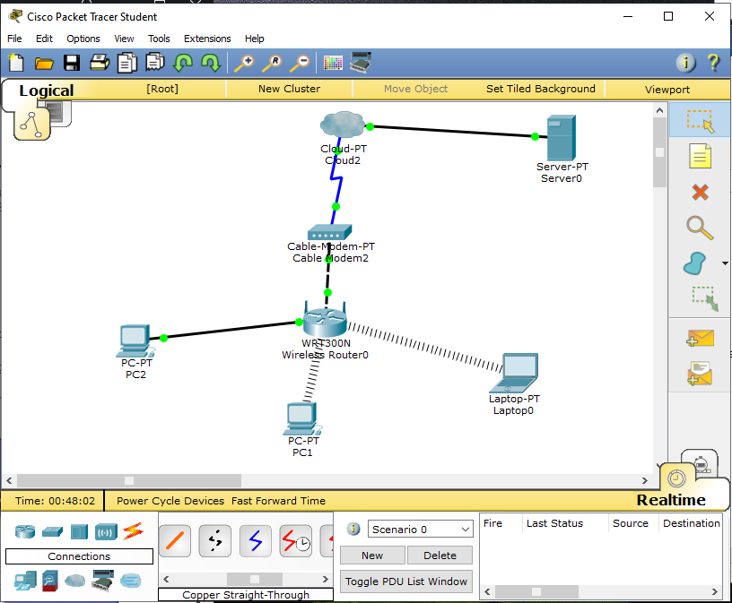
4. Configure Wireless router  
   Click on the Wireless Router icon on the Packet Tracer Logical workspace to open the device configuration window.   
   In the Wireless Router configuration window click on the GUI tab to view configuration options for the Wireless Router.   
   Next, click on the Wireless tab in the GUI to view the wireless settings. The only setting that needs to be changed from the defaults is the Network Name (SSID). Here, type the name “HomeNetwork” as shown in the figure  
   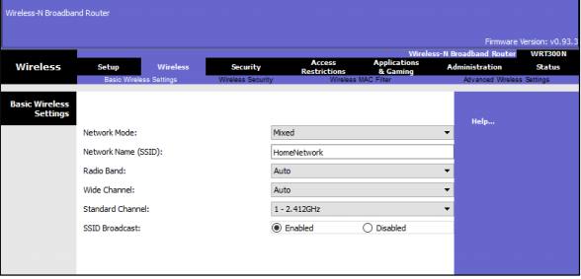  
     
   Configuring internet connection on router.  
   Click on setup tab and under DHCP server settings, Verify that it is Enabled and configure static IP address of DNS server as 208.67.220.220  
   Click on Save settings.  
   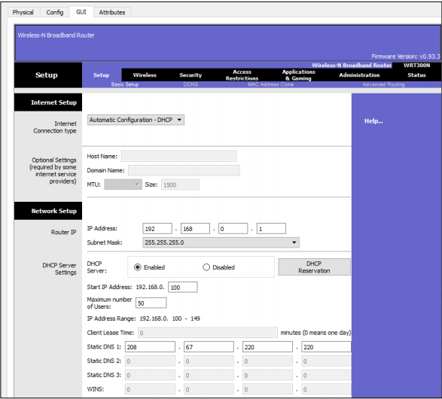
5. Configure laptop  
   Click on laptop and under physical tab, remove default ethernet copper module and replace with the wireless WPC300N module.  
   Power off Laptop, remove ethernet copper module and put new WPC300N module by dragging from left pane to empty slot. Turn on the power.  
   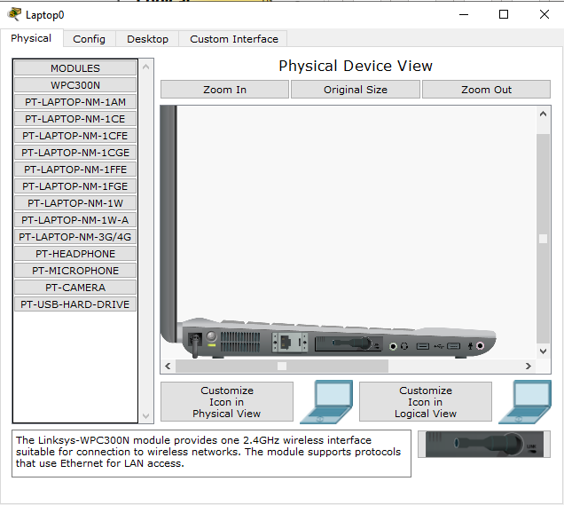  
   Connecting laptop to wireless router.  
   Click on Desktop tab and select PC Wireless icon. Under the connect tab, choose the SSID of router and click connect.  
   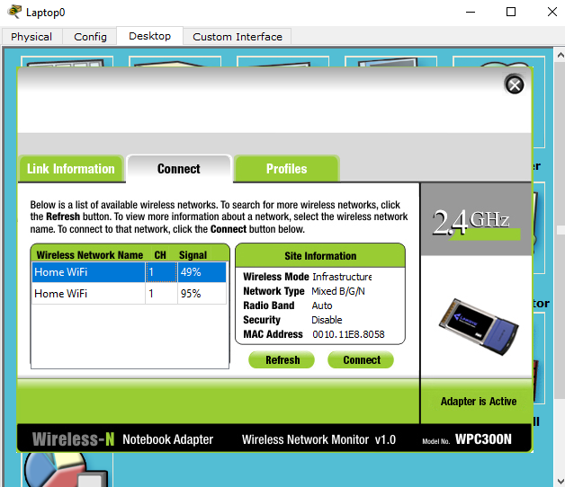
6. Configure the PC  
   Click on the PC and under desktop tab, click on IP configuration. Select DHCP and PC will get an IPv4 address.  
   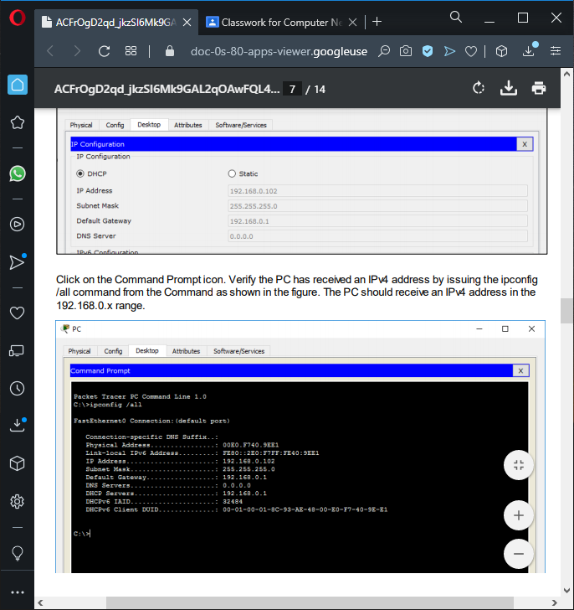  
   Click on command prompt under desktop and type following command: ipconfig /all and note down the IP address  
   
7. Configure the internet cloud  
   Install network modules if necessary.  
   Necessary modules: PT-CLOUD-NM-1CX (to connect cable modem) & PT-CLOUD-NM-1CFE (to connect to server). Identify the from and to ports.  
   Click on the config tab, click on connections under cable and select Coaxial under 1st drop down and ethernet under 2nd drop down. Next, click on the Add buttons  
   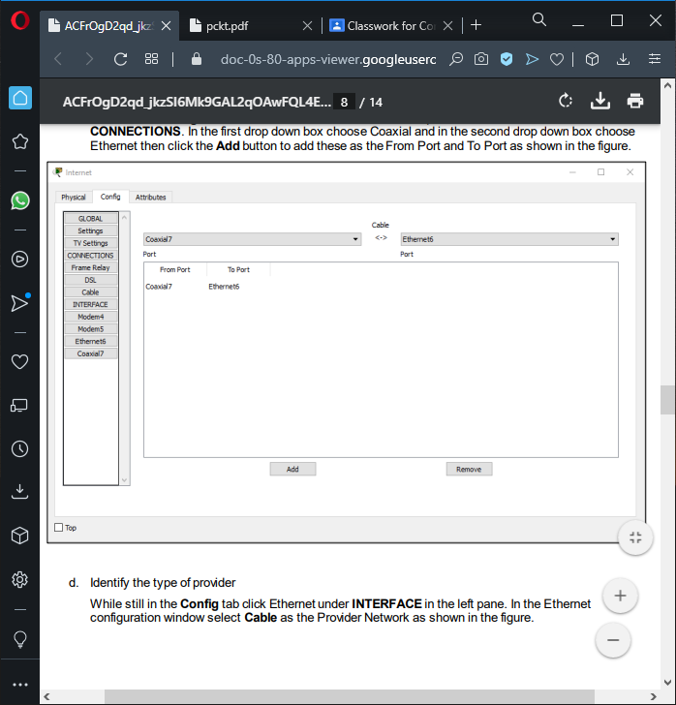
8. Identify type of provider  
   In the config tab click Ethernet under INTERFACE in the left pane. In the ethernet window, select Cable as the provider network  
   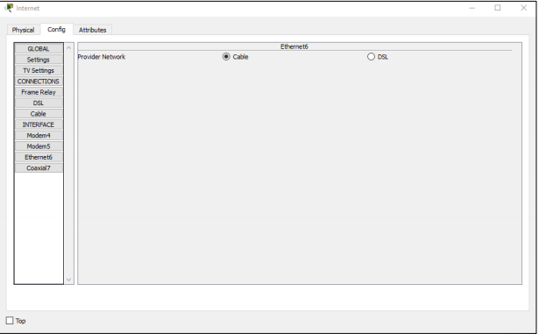
9. Configure server  
   Click on server and configure as a DHCP server.  
   Click on server and select Services tab. Select DHCP from SERVICES list in left pane.  
   Turn On the DHCP service and Pool name: DHCP pool  
   Default gateway & DNS Server: 208.67.220.220  
   Starting IP Address: 208.67.220.1  
   Subnet mask: 255.255.255.0  
   Max no. of users: 50  
   Next, click on Add to add the pool.  
   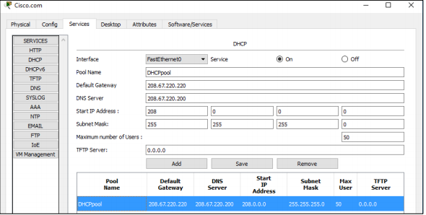  
     
   Configure the DNS service using the following settings as shown in the figure.  
    • Click On to turn the DNS service on   
   • Name: Cisco.com   
   • Type: A Record   
   • Address: 208.67.220.220   
     
   Click Add to add the DNS service settings.  
   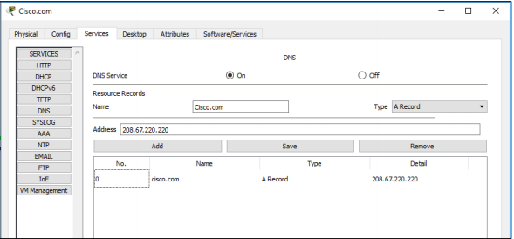  
     
   Configure global setting under config.  
   Select Static and Gateway: 208.67.220.1 & DNS Server: 208.67.220.220  
   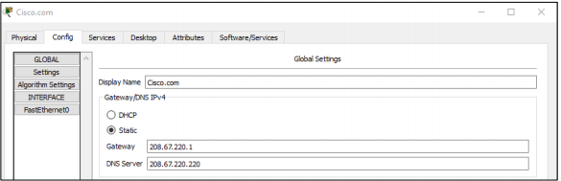  
     
   Configure server:  
   Click on FastEthernet in left pane in config tab. Configure as follows:  
   Select static under IP configuration. IP address: 208.67.220.220 & 255.255.225.0  
   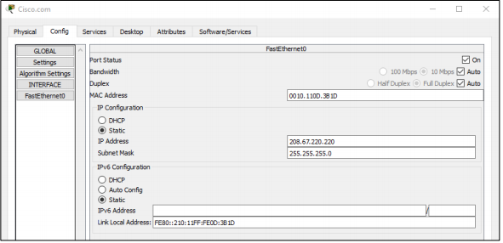
10. Verify connectivity  
    Refresh the IPv4 settings on the PC   
    a) Verify that the PC is receiving IPv4 configuration information from DHCP.   
     Click on the PC on the Packet Tracer Logical workspace and then the select the Desktop tab of the PC configuration window.   
     Click on the Command Prompt icon In the command prompt refresh the IP settings by issuing the commands ipconfig /release and then ipconfig /renew. The output should show that the PC has an IP address in the 192.168.0.x range, a subnet mask, a Default Gateway, and DNS server address as shown in the figure.  
    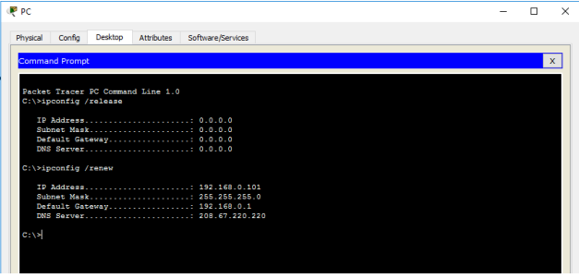
11. Test connectivity to the server from PC.  
    Type command: ping Cisco.com  
    If response is successful, everything works correctly.  
    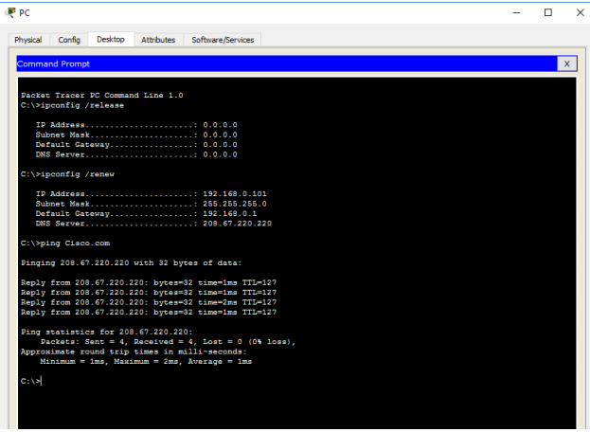

**Conclusion: Thus we connected LAN system to internet using a dummy internet cloud and server.**